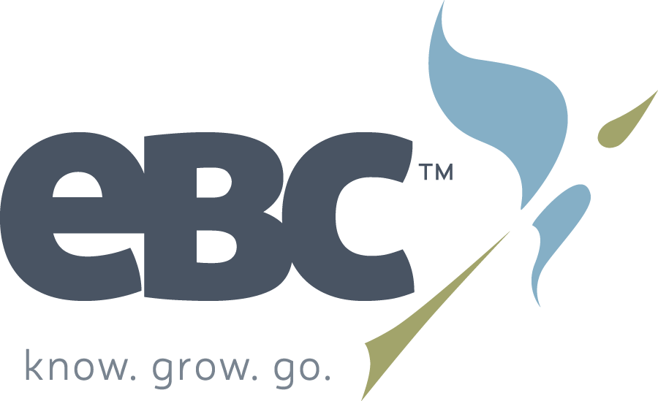

Youth Position at Evangelical Bible Church (Dallas, Oregon)

Hello! Evangelical Bible Church in Dallas, Oregon is in the process of searching for our new youth pastor. If, after looking through this information, you would still like your name to be considered for this position, please fill out the attached form and mail or email it back to us. This allows us to give our search team a standardized way to compare qualified candidates. You are also welcome to include a picture or attach a resume.

Here are a few short answers to questions that you may have:

What is the nature of this position?
We are looking for a person to manage and oversee the youth ministry at EBC. This primarily includes the Middle School and High School groups. The gifts, background, and experience of the person we hire will help to determine the specifics of the job. Salary range is 40k-46k depending upon experience.

Why is EBC looking for a new youth pastor?
EBC has been blessed by a solid youth ministry for many years. We are hoping to continue that fact. Our current Youth Pastor, Andrew Wheeler has recently expressed a desire to follow God’s leading into another ministry role.

What is EBC looking for in a youth pastor?
We are looking for someone who loves God and people (particularly students and their families). We are also looking for someone who is a good fit for our church and community. While there will undoubtedly be many qualified and godly applicants, finding someone who embraces our values and will feel at home ministering in our community will be essential.

How can I find out more about EBC and the community of Dallas, Oregon?
Here are some important links to help you consider whether we might be a good fit for you:
Ebcdallas.org our website
Fellowshipforward.org Denomination site, with belief statements and position papers.
Sperlings Great Places More about our town and community
Dallas City Page Official town website

First Steps:
If, after considering the above information, you are interested in continuing further, you can email the
initial questionnaire to ebcdallas.search@gmail.com Please include “YOUTH POSITION” in the subject line.

Thank you for your time. We pray God’s very best for your future.

Youth Position Evangelical Bible Church, Dallas Oregon

Personal Information

Name:
Birthdate:
Highest degree earned and institution:
Are you married? Yes No
If no, have you ever been married? Yes No N/A
If yes, is this your first marriage? Yes No N/A
Additional comments:
Do you have any children? Yes No
Are you a U.S. citizen or permanent resident? Yes No
If no, please explain:
Take a few sentences to tell us about yourself and/or family:

Briefly share your personal testimony.

Why might you be interested in working with the youth at EBC?

Evangelical Bible Church, Statement of Faith:
Please look over the attached Statement of Faith at https://ebcdallas.org/about/statement-faith. Please indicate any areas that do not match your personal beliefs.

I am in complete agreement with the statement of faith.

I have some minor disagreements with the statement of faith, as written. (Please indicate differences on a separate sheet of paper).

I have some significant disagreements with the statement of faith. (Please indicate differences on a separate sheet of paper).

Also, for your own information, position papers can be found at https://www.fellowshipforward.org/beliefs.html

